Monitoring and Logging

Part -1 Monitoring Infrastructure, Application and Database Metrics
I have create monitoring metrics using Prometheus, Grafana, Node exporter, Blackbox exporter, AWS CloudWatch.
1) I have installed Grafana and Prometheus in one ubuntu server and Node and Blackbox exporter in application server.
2) I have configured CloudWatch and Prometheus as data source for Grafana and I Have created a metrics via PromQL and CloudWatch metrics
I have created Infrastructure metrics like CPU,RAM and DISK using Prometheus and node exporter data source.
- CPU PromQL Query for this is
100 - (
avg by(instance) (irate(node_cpu_seconds_total{mode="idle"}[5m])) * 100 +
avg by(instance) (irate(node_cpu_seconds_total{mode="iowait"}[5m])) * 100)
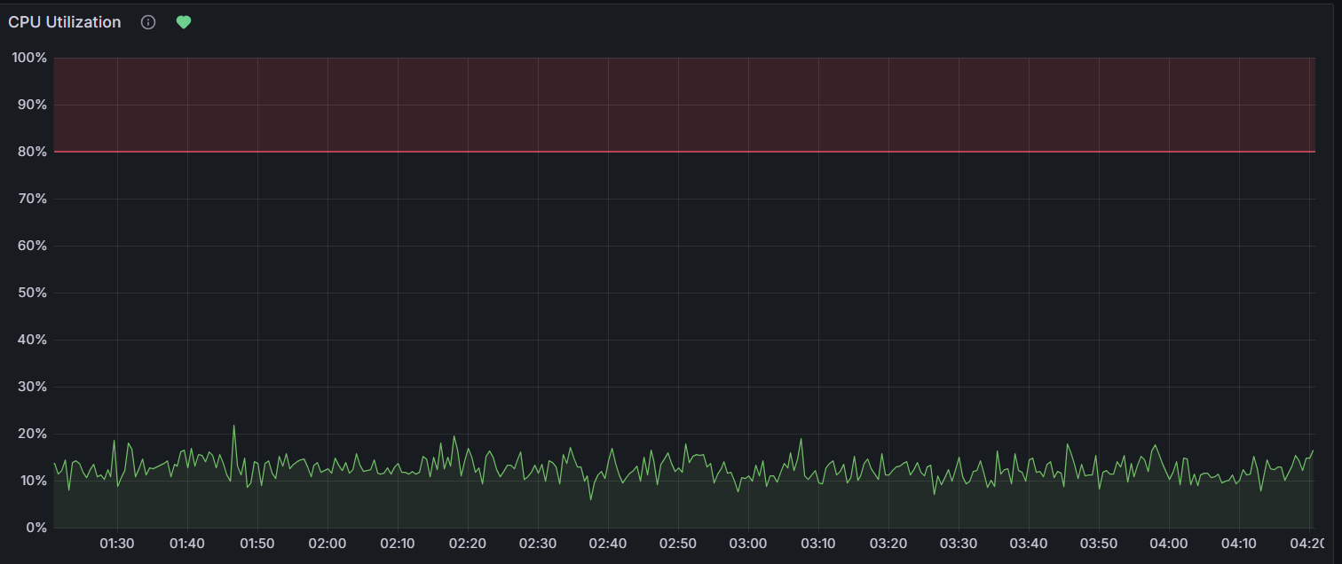

- RAM PromQL Query for this is
100 * (1 - ((avg_over_time(node_memory_MemFree_bytes{job=~"node_exporter"}[30d]) + avg_over_time(node_memory_Cached_bytes{job=~"node_exporter"}[30d]) + avg_over_time(node_memory_Buffers_bytes{job=~"node_exporter"}[30d])) / avg_over_time(node_memory_MemTotal_bytes{job=~"node_exporter"}[30d])))
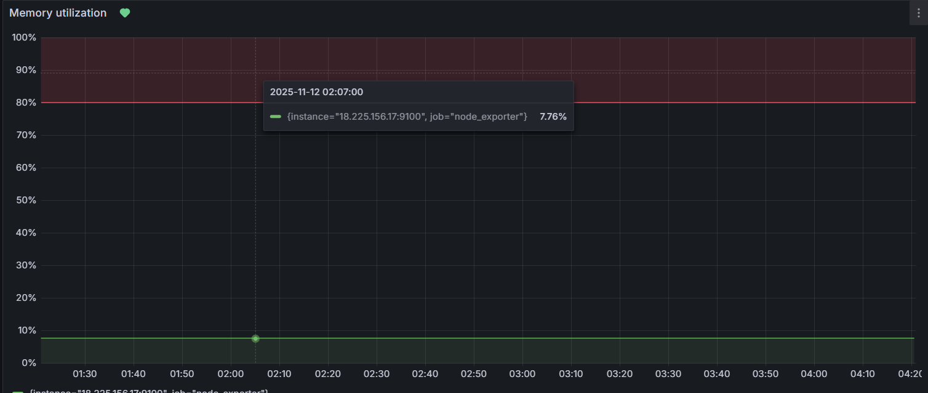

- DISK
100 - ((node_filesystem_avail_bytes{mountpoint="/",fstype!="rootfs"} * 100) / node_filesystem_size_bytes{mountpoint="/",fstype!="rootfs",instance="18.225.156.17:9100"})
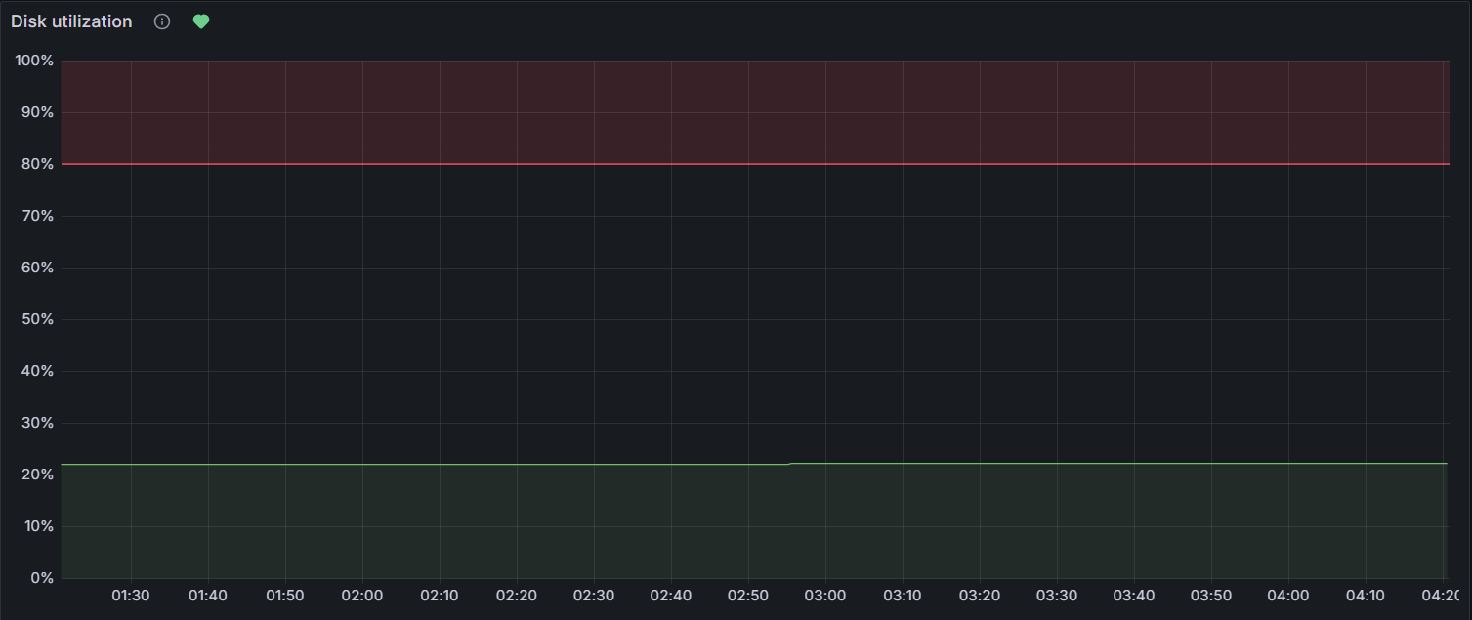

I have created Application metrics like Request rate, Error rate and Average response time or latency using Prometheus and Blackbox exporter data source.
- Request rate
rate(http_requests_total{alias="production-angular-apache", code="200", instance="3.216.28.228:9117", job="production-angular-apache"} [1m])
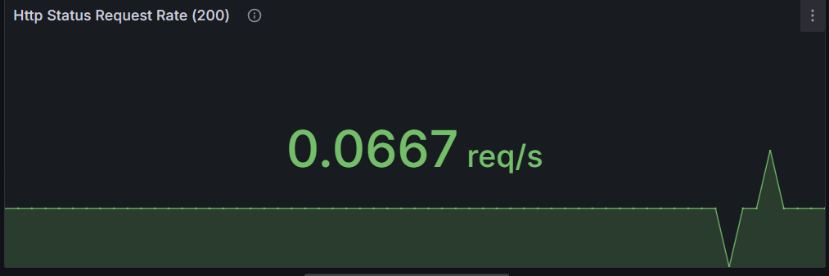
- Error Rate


- Latency or Average Response time
probe_duration_seconds
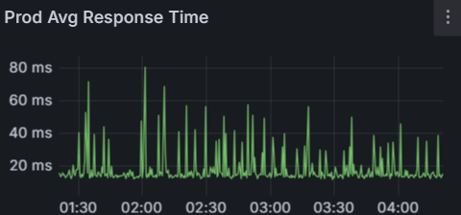
I have created Database Using AWS CloudWatch data source.
